Lab 3: Stability Analysis

EEE4514

February 22, 2017

**Gabriel Stroe**

# Filtering

## Overview

The purpose of this lab is to show the difference between stable, marginally stable and unstable systems. We will also be looking at the open-loop position and speed response of the servo motor.

## Theory and Methods

The basis of this lab relies on the servo’s voltage to speed transfer function which is represented below:



Here, K = 23 rad/(V-s) and T = 0.13 s. K is the gain for the servo motor and T is the time constant. This system is inherently stable as it does not have any poles in the right half plane in the s-plane. Here we will apply a constant voltage to the system and show how it will rotate the servo motor without having the system reach unstable speeds.

In its voltage to position function the system is only marginally stable as a pole exists right on the imaginary axis:



## Results

This is a fairly straight forward lab were the we can see exactly how the position and speed of a system change as the voltage is applied. Below is an output graph of each item. As you can see the position moves very constantly as the velocity peaks and reaches a stable output.  
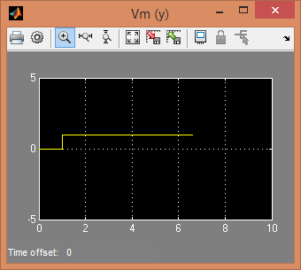

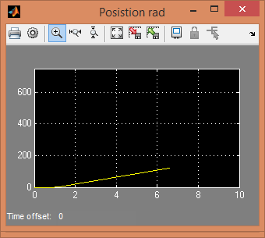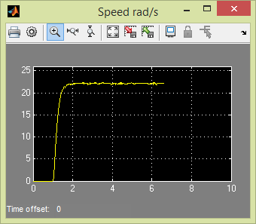

## Questions

1. The system is stable as no poles exist in the right half plane, only in the left half.
2. The system is marginally stable as a pole exist right on the imaginary axis.
3. For speed the bounded input of voltage also corresponds with a bounded output of velocity. This matches our poles analysis. For position the bounded input of voltage does not correspond with a bounded output of position making it unstable. This is different from the pole analysis as that determined the system was marginally stable.
4. The system is not stable based on position as outlined in question 4.
5. Yes, an impulse input or any input who’s integral is not infinity as t goes to infinity would bound this function. With that said any function who’s integral is bounded as t goes to infinity would mean that the system is marginally stable.

## Conclusions

From this lab we have learned how to define bounded system and unbounded systems and what that means in terms of stability. A quick pole analysis seems to be the easiest and most effective way of determining if a system is stable, marginally stable, or unstable. But for some systems where this is too complicated to analyze the poles or the transfer function is unknown, then using the BIBO method would also allow us to understand the same things.